**Accounting Software**

1. Login Page for Register User:-

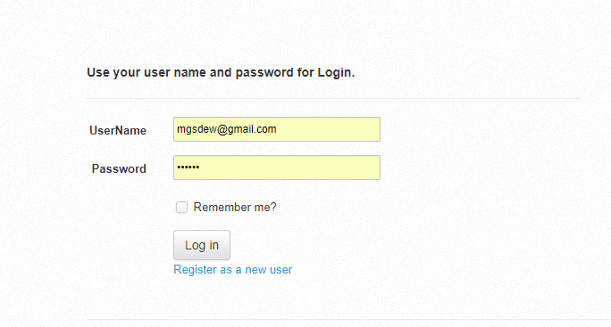

1. Registration Page for New User  
   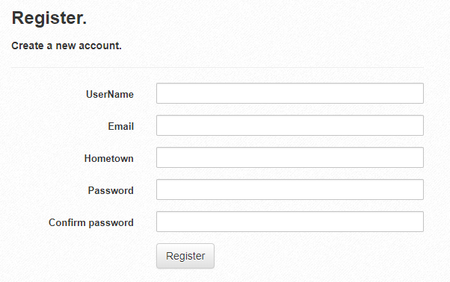
2. Dashboard   
   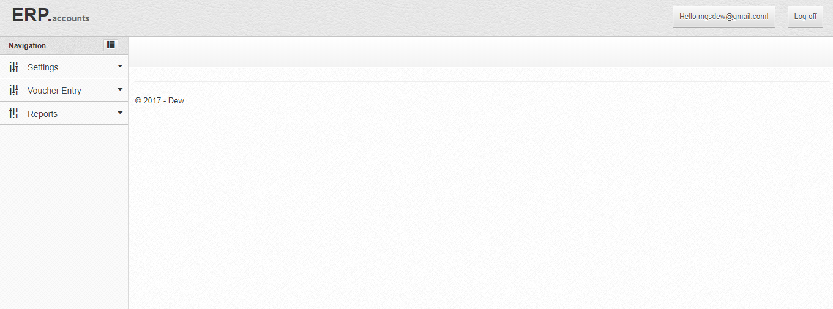
3. Setting Page of Company  
   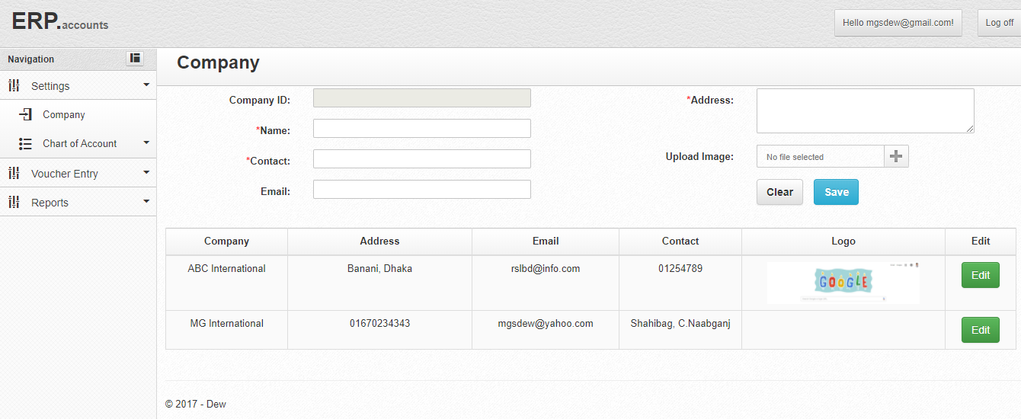
4. Setting Page for Chart of Account  
     
   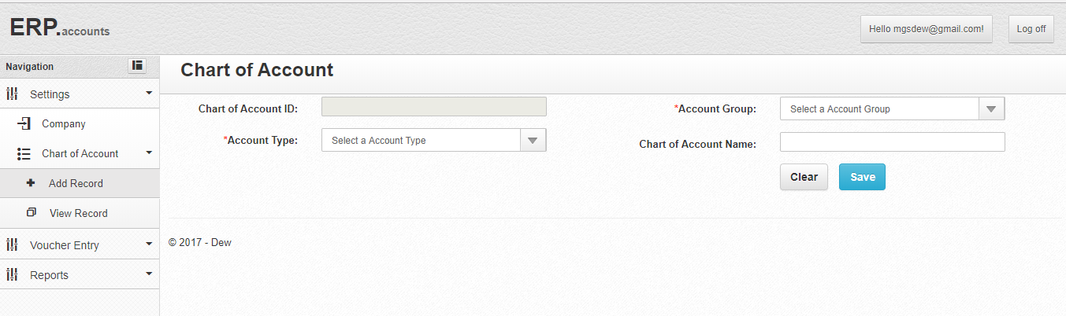
5. View Page of Chart of Account  
   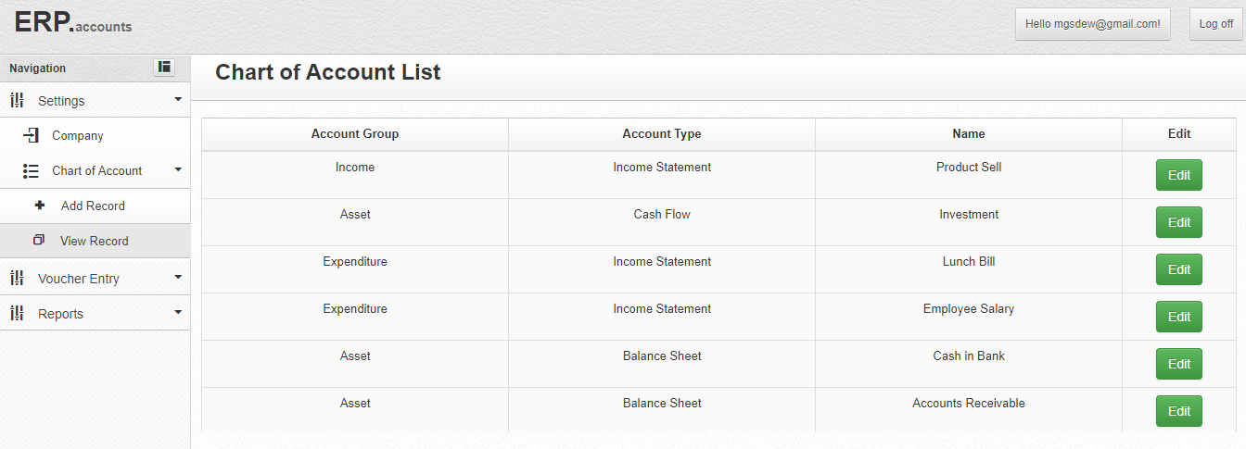
6. Edit Page of Chart of Account  
   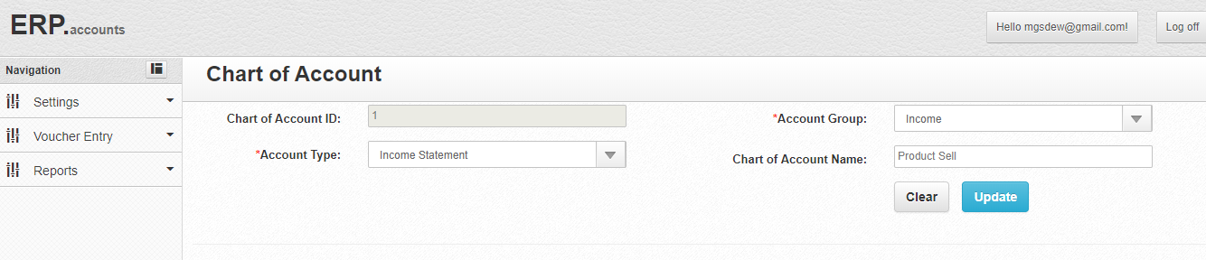
7. Entry form Journal Voucher  
   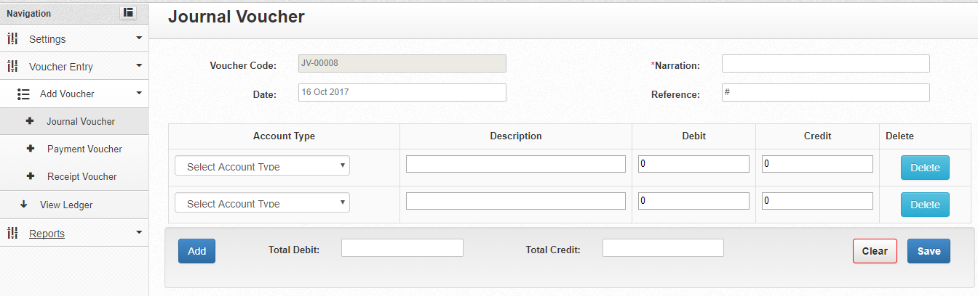

**Select Accounts from Select Box (**Here you can select from **all of the 4 groups of account)**  
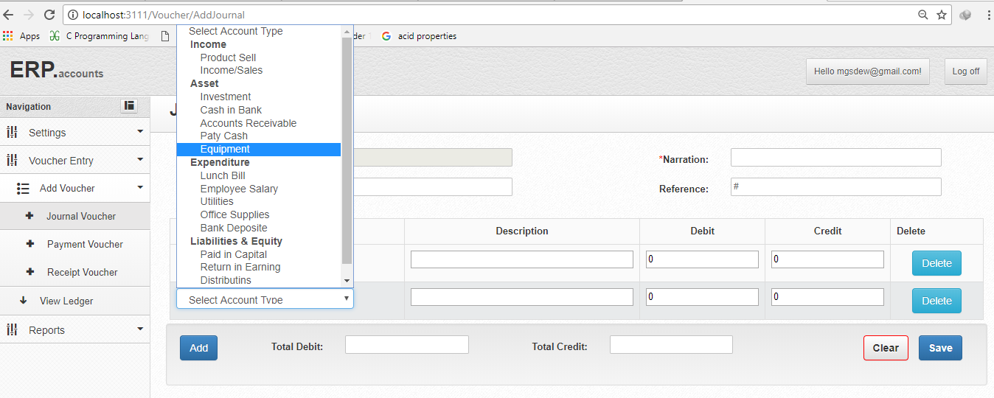

1. Entry Form of Payment Voucher (Account Type selection will be same as Journal Voucher)  
   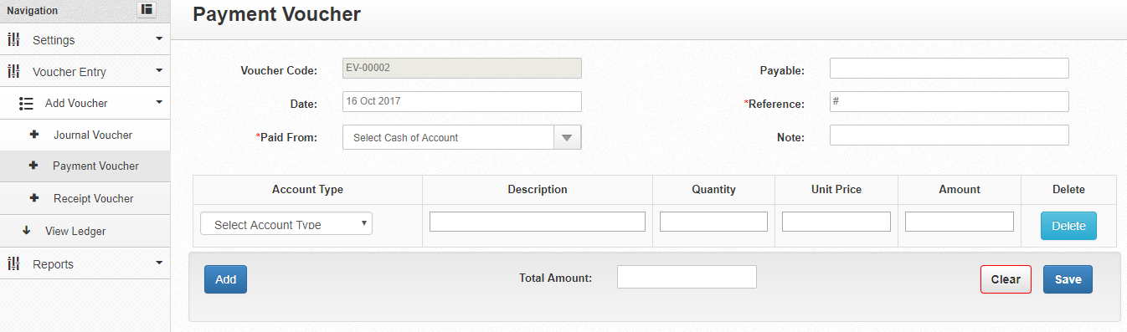  
    **Select Accounts from Select Box (**Here you can select only **expenditure account type)**  
   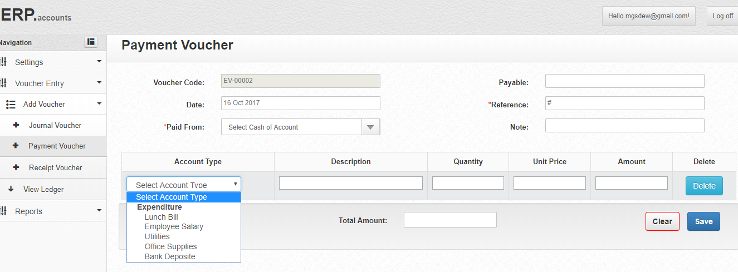
2. Entry Form of Receipt Voucher  
     
   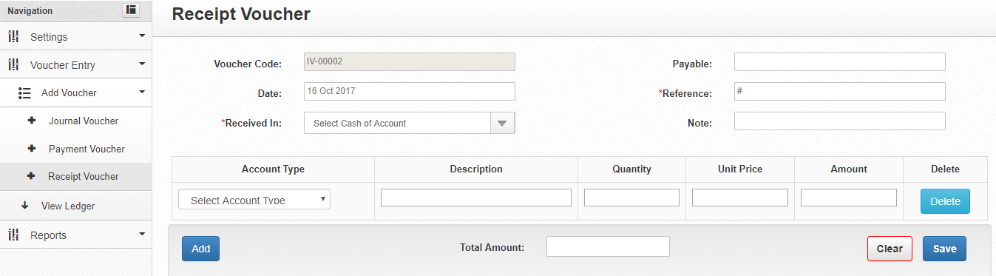  
   **Select Accounts from Select Box (**Here you can select only **income account type)**  
   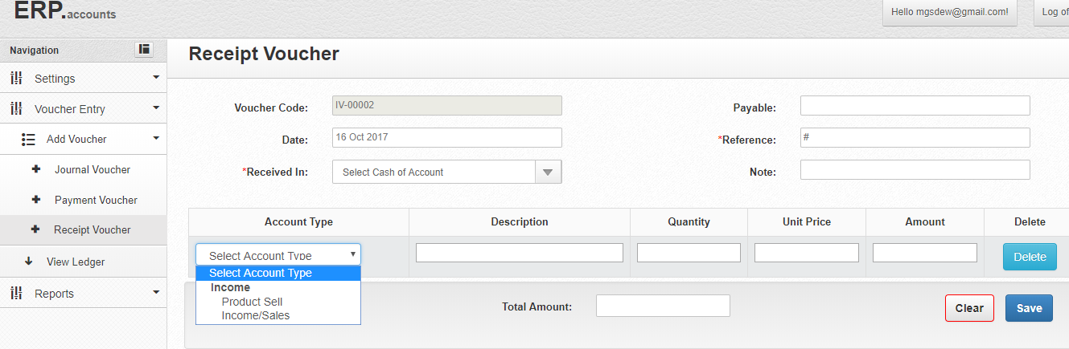
3. Voucher List View Page (You can search/view Voucher using date or individually. Also can Edit them from here and generally by clicking **View** button you will see report)   
   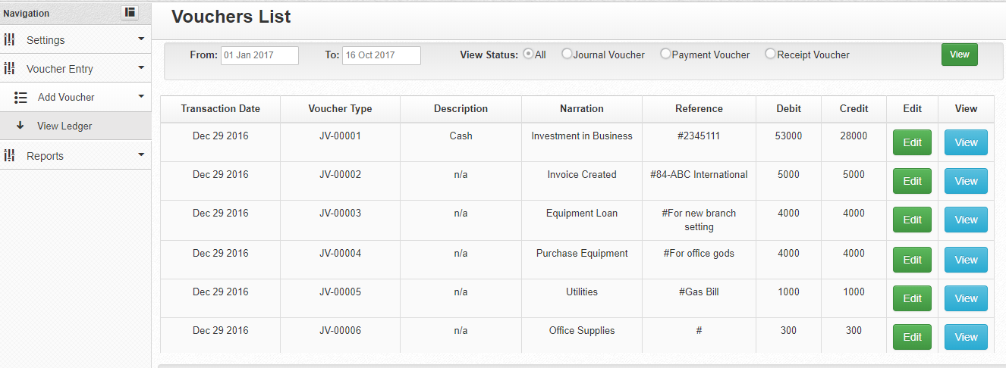

**Report for Journal Voucher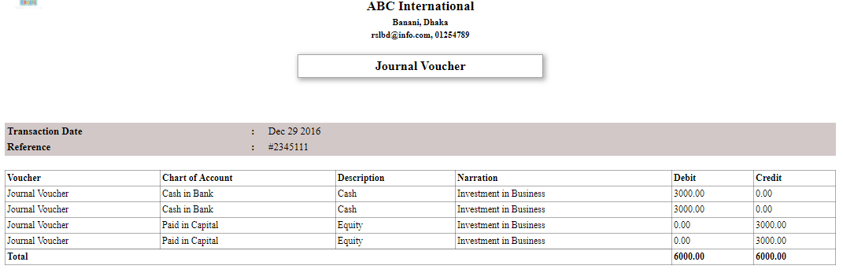 Report for Payment Voucher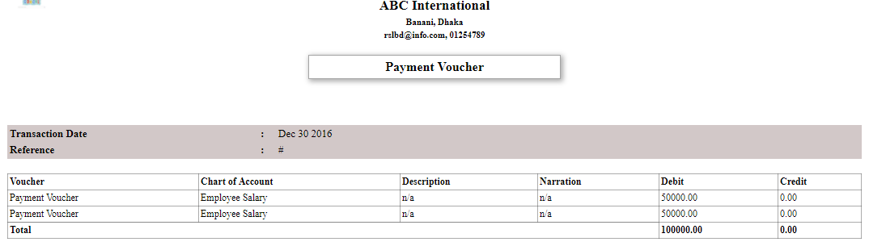 Report for Receipt Voucher**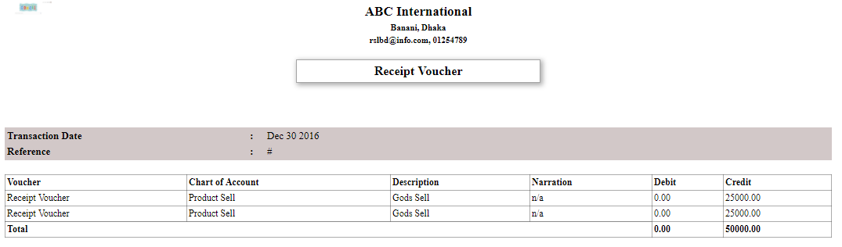

1. Final Report Page (You should select Date and an option for which report you want to see)  
   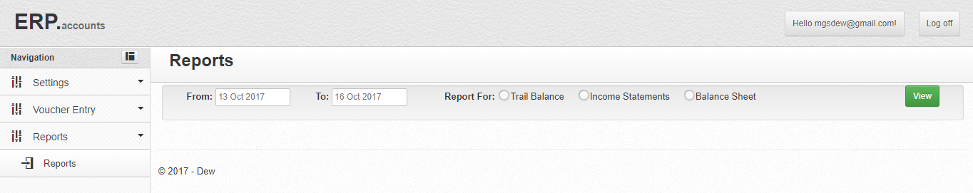  
   **Report for Trial Balance**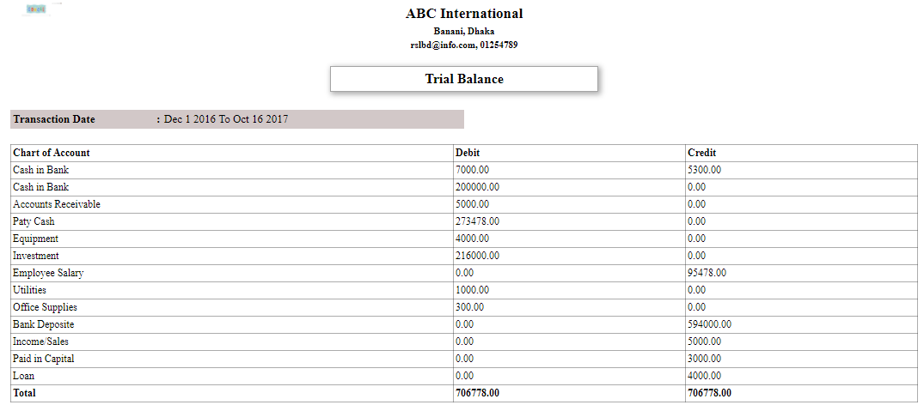

**Report for Income Statement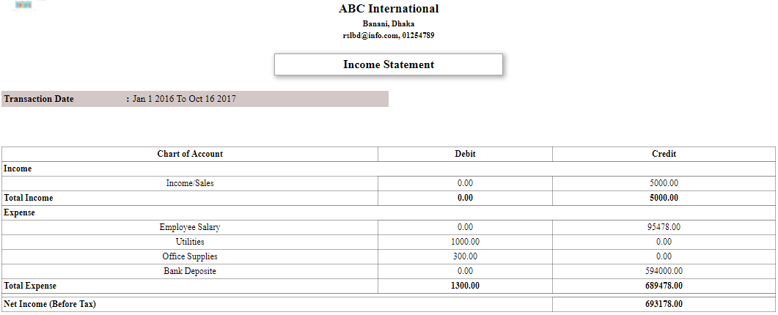 Report for Balance Sheet**